Create Object Storage with ORM Stack

Contents

1. Introduction 1
2. Workflow diagram to deploy the stack 1
3. Create stack for Object Storage 2
4. Plan the Job 5
5. Apply the Job 6
6. Verify in the Console 8
7. Destroy the stack (if required) 8

Introduction

The Oracle Cloud Infrastructure Object Storage service is an internet-scale, high-performance storage platform that offers reliable and cost-efficient data durability. The Object Storage service can store an unlimited amount of unstructured data of any content type, including analytic data and rich content, like images and videos.

With Object Storage, you can safely and securely store or retrieve data directly from the internet or from within the cloud platform. Object Storage offers multiple management interfaces that let you easily manage storage at scale. The elasticity of the platform lets you start small and scale seamlessly, without experiencing any degradation in performance or service reliability.

Workflow diagram to deploy the stack

Below diagram shows how the Terraform Artifact are applied in the OCI. While creating a ORM stack, using terraform deliverables Init, Plan and Apply is the flow to provision the resource in the OCI. We can have the deliverables in any of below.
- GitLab/GitHub Repo
- Bitbucket
- Can be in folder/.zip in the local disk
- Object Storage Bucket
- Can be in compartment
- Oracle provided Template


Create stack for Object Storage

Go to OCI Console Developer Services Resource Manager Stacks select the compartment Create Stack

My Configuration Folder Browse Select the “Object storage” folder that contains the artifacts Upload

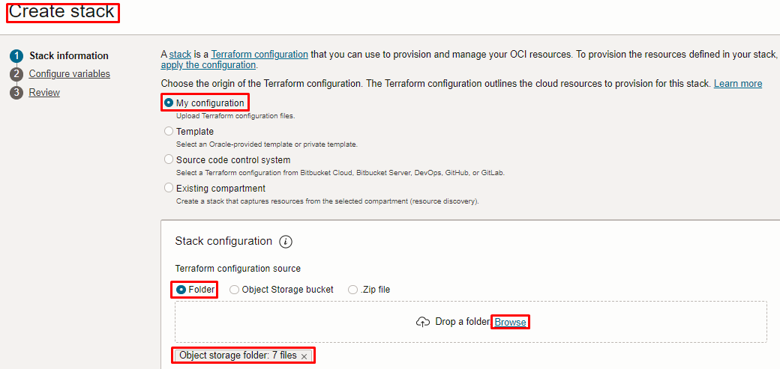
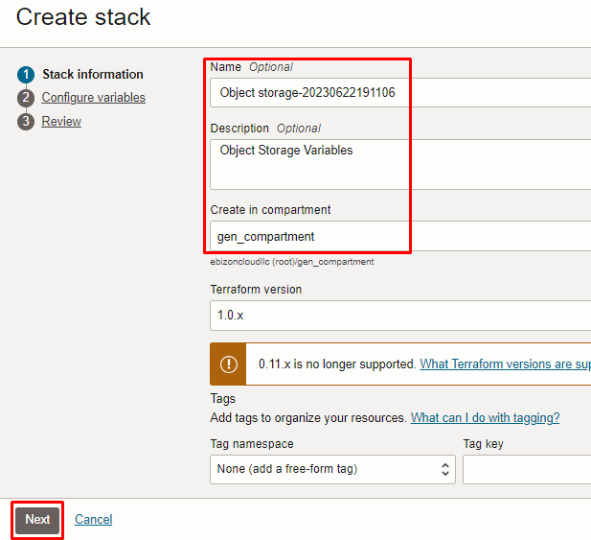

Click “NEXT”

Select the parameters as per the below screen,

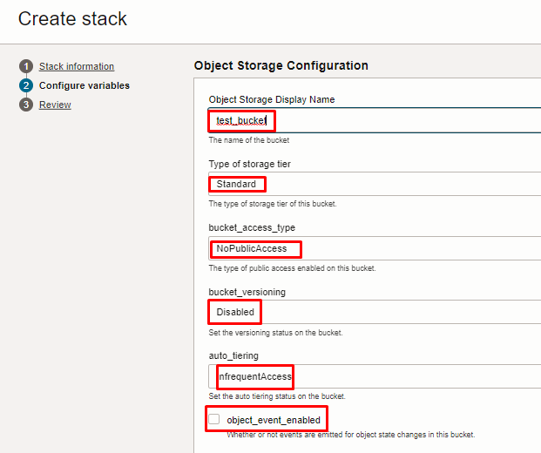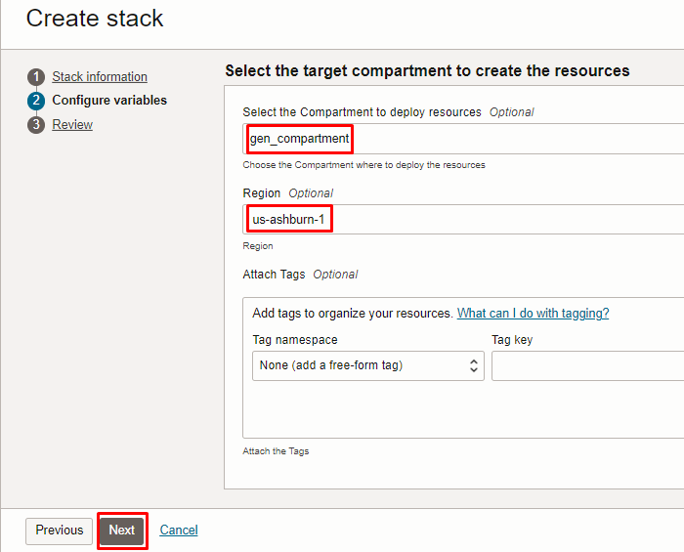

Note: select the right compartment to apply the stack in the OCI

Click “NEXT” Click “CREATE”

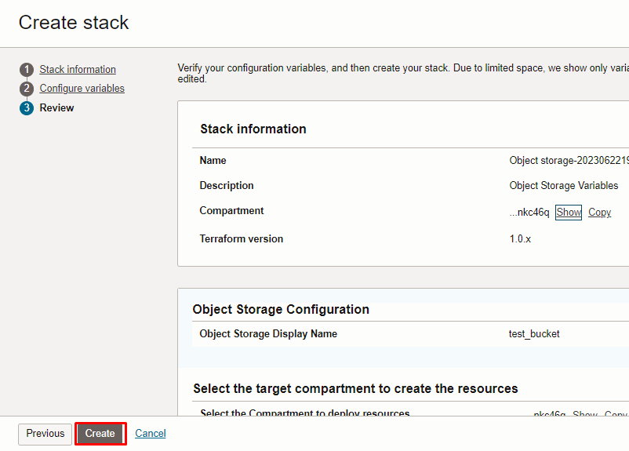

Plan the Job

Click the “Plan”

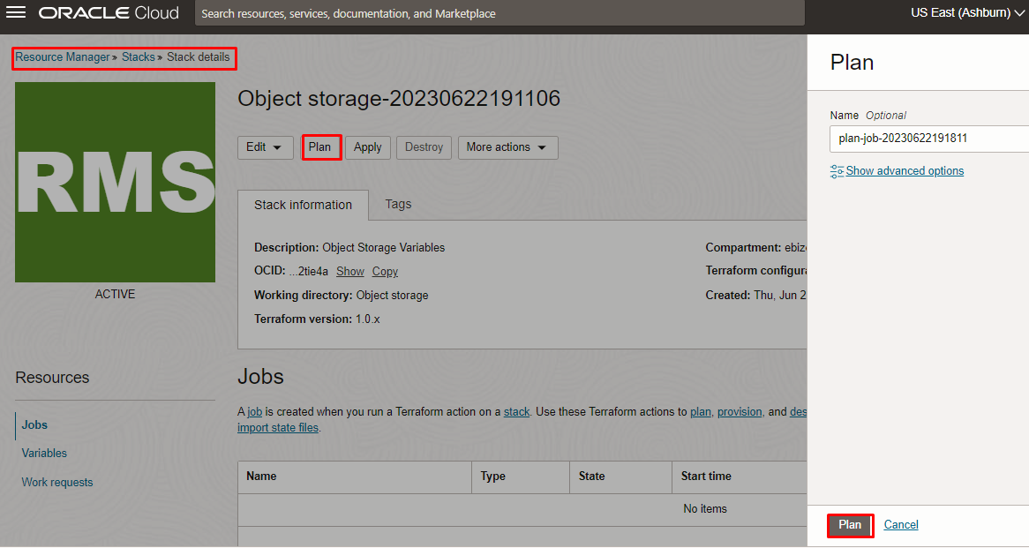

Verify the Plan is successful.

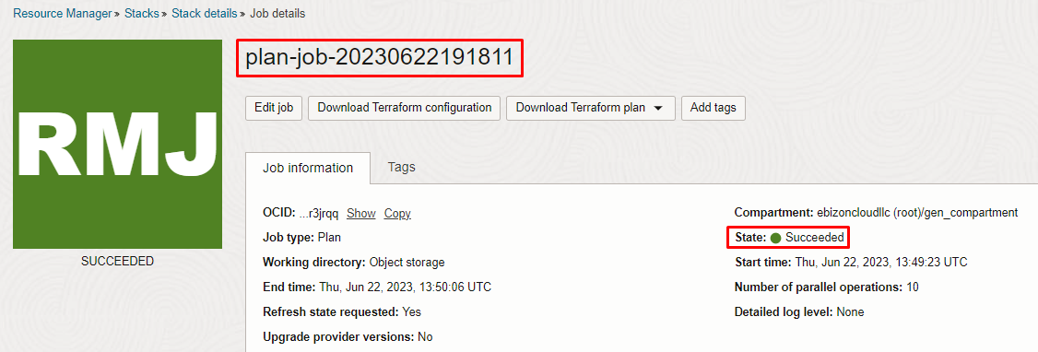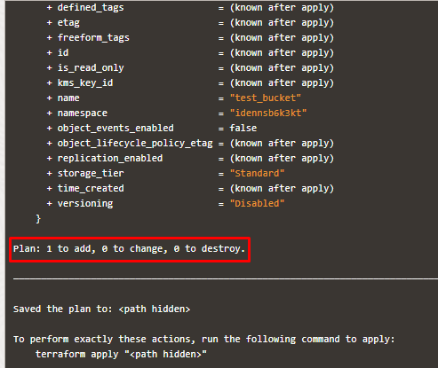

Apply the Job

Once the “plan” is success, now click “Apply”

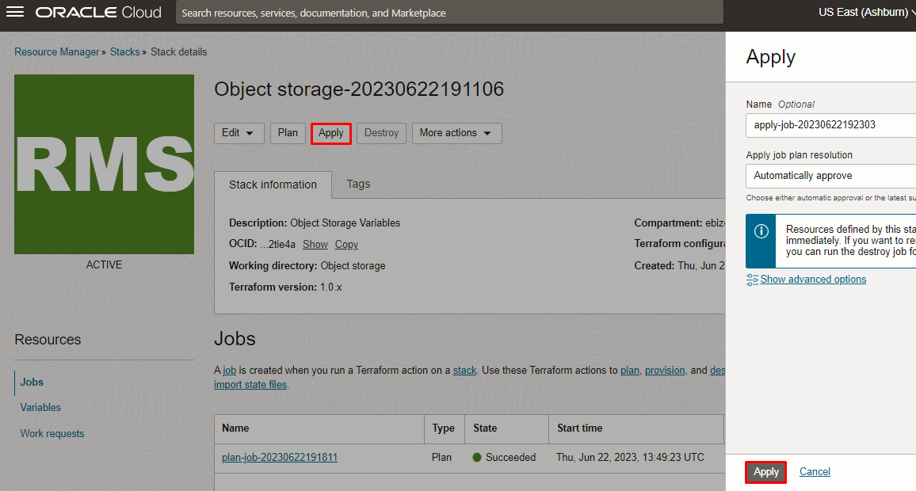

Verify the Apply is successful.

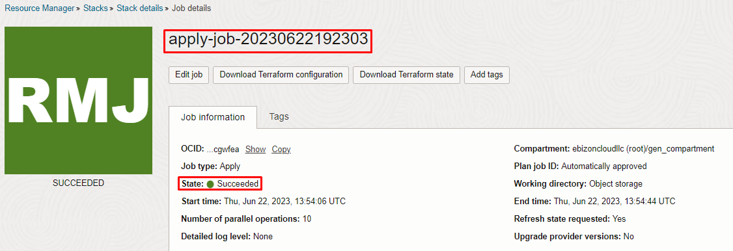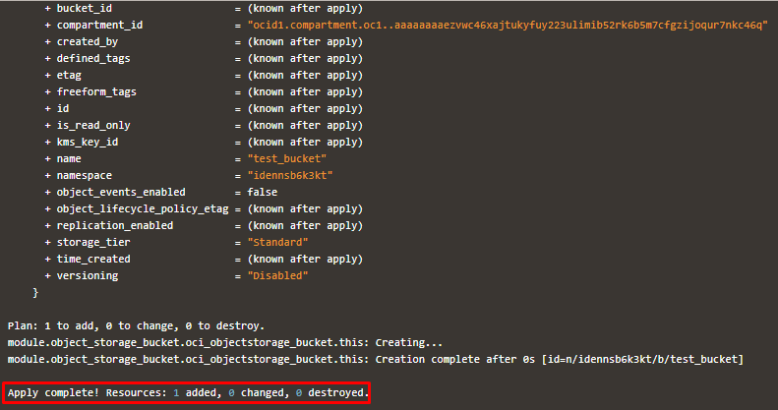

Verify in the Console

Go to OCI Console Storage Buckets
Note: Select the specified compartment (in the step 2) to get the output.

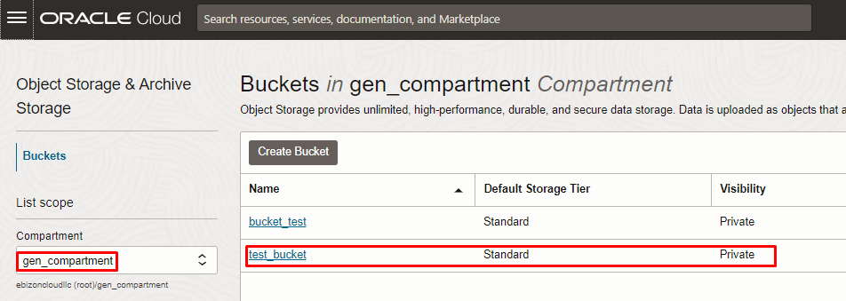

Destroy the stack (if required)

Create a destroy job in Resource Manager to release resources associated with a stack and clean up the tenancy. Once destroyed data cannot be recovered from resources.

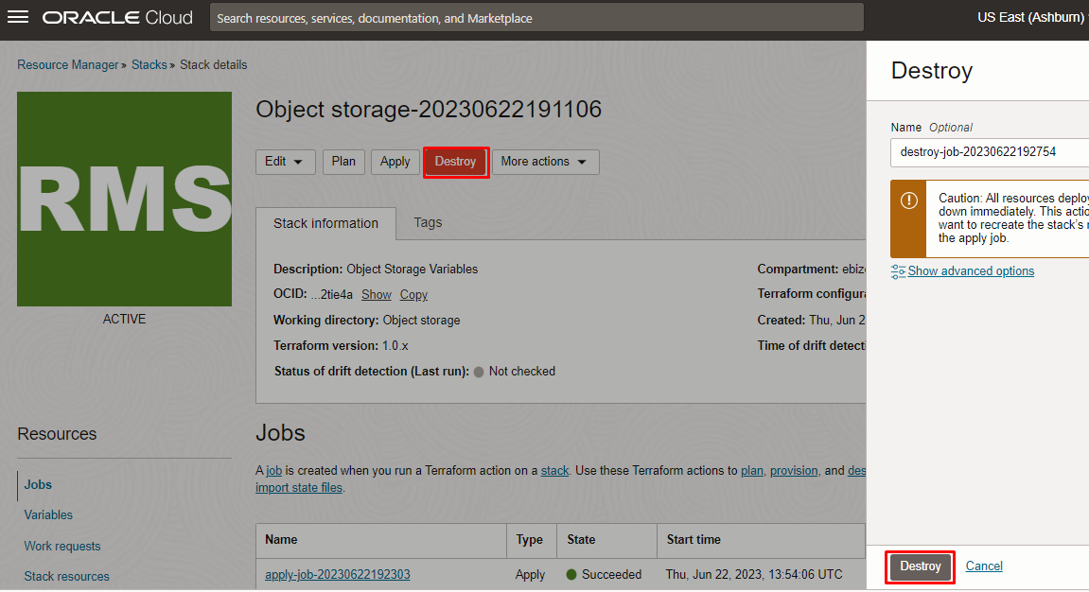

# END #

